**THE UNIVERSITY OF HONG KONG**

**FACULTY OF SCIENCE**

**SCNC1111 Scientific Method and Reasoning**

**Semester 2, 2019/20**

**Guidelines for Online Tutorials**

Due to class suspension, supplementary online sessions for tutorials will be conducted during weeks 2 and 3 (from 3rd February to 14th February). This is to enhance your understanding of the course materials.

Besides instructional materials and videos for tutorials, we will host **optional Question and Answer (Q&A) sessions online through Skype for Business**. The Q&A sessions will be hosted at the original time for the tutorial group you have enrolled in. A link for the Skype meeting will be posted under the specific section for your tutorial group on the course Moodle. Below are the specific guidelines for the online tutorial sessions.

**Before the Online Tutorials:**

You should have installed a functional copy of **Skype for Business** (see a) or a copy of **Skype Meetings App** (web) (see b). **Please note that Skype (for Consumer) does not work for this purpose.**

Please work on the assigned tasks and read relevant materials on Moodle beforehand to prepare yourselves for the online sessions.

1. Set up Skype for Business using your HKU Office 365 subscription

As HKU students, you are entitled to a free Office 365 subscription allowing installation of Microsoft Office programs on a maximum of 5 devices.

You can sign in to your Office 365 subscription via <https://www.office.com/> using your HKU email address ([UID@**connect.hku.hk**](mailto:UID@connect.hku.hk)). You should be redirected to a page titled “The University of Hong Kong - Microsoft Office 365 for **Students**” (Appendix Figure 1); you can then proceed to log in using your HKU Portal login credentials.

After logging in, you can go to Install Office > Install Software and this will take you to <https://portal.office.com/>. Select Apps & Device and download Skype for Business. After installation, you can use your HKU email address ([UID@**connect.hku.hk**](mailto:UID@connect.hku.hk)) to log in to Skype for Business app.

Note: If you encounter an error saying “Can’t sign in to Skype for Business”, you can try to click the “Delete my sign-in info” button below your sign-in address and type in your login credential again (Appendix Figure 2). If it does not work, you can use the Skype Meetings App (web) client (see b).

Further details on using Skype for Business and installation guide for the mac version can be found in [User Guide on Skype for Business](https://www.its.hku.hk/documentation/guide/communication/im/skype-for-business) by HKU ITS.

1. Set up Skype Meetings App (web)

In case you cannot install or log in to Skype for Business, you can install Skype Meetings App (web) by following the on-screen instructions in the link for the Skype session. The link will be displayed on the course Moodle a day before the start of the tutorial sessions.

**During the Online Tutorials:**

You will be provided with a meeting link to access the Skype session on Moodle under the section specific to the tutorial group you have chosen (i.e., if you are enrolled in Group Iodine, the section heading will be “Group Iodine [Tuesday 10:30 - 11:20 MB141]”). After clicking the link, you will be able to join the online tutorial during the original timeslot of the tutorial by following the on-screen instructions.

Please type your questions using the message box as it is difficult to accommodate everyone talking simultaneously.

Tutors will give more elaborations on the tutorial notes to help with your understanding of the course materials as necessary. Therefore, you are highly encouraged to join the online tutorial sessions.

**After the Online Tutorials:**

If you have any questions on the course content after the online sessions, please do not hesitate to discuss on our Moodle forum or send your inquiries to our course email [hku.scnc1111@gmail.com](mailto:hku.scnc1111@gmail.com).

We will host the first Q&A session on 4 February, 2020 (Tuesday). You are strongly encouraged to join this session to enhance your understanding of the tutorial content, exchange opinions with fellow students, and get to know your potential project group mates. Should you have any enquiries on the arrangement of online tutorial sessions, please contact us by email.

**Appendix**

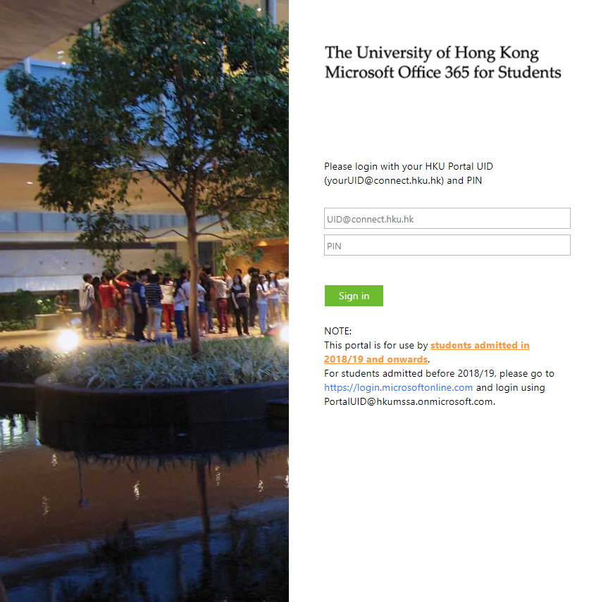

Figure 1: The University of Hong Kong - Microsoft Office 365 for Students Sign In Page

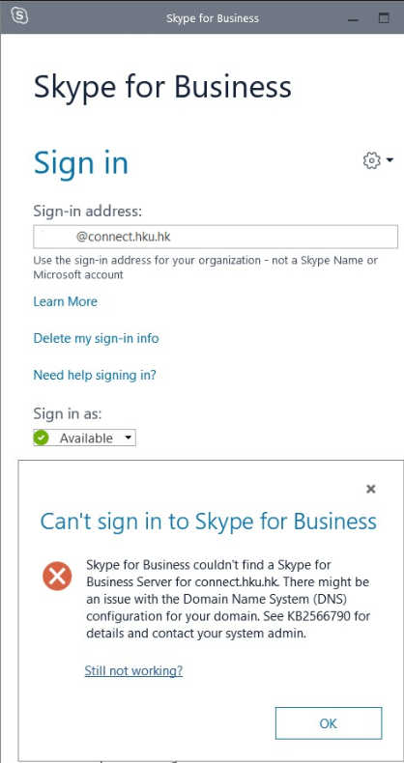



Figure 2: Click “Delete my sign-in info” in case you encounter error “can’t sign in to Skype for Business”